CLASS XII
INFORMATICS PRACTICES PROJECT

HYBRID SALES AND PROFIT
ANALYSIS SYSTEM
CSV-Based Business Data Analysis

School Name | ________________________________________
School Logo | Not provided
Student Name | ________________________________________
Roll Number | ________________________________________
Class and Section | ________________________________________
Subject | Informatics Practices
Subject Code | 065
Academic Year | 2026–2027

4. Table of Contents (Index)
S No. | Topic | Page
1 | Cover Page | 1
2 | Certificate | —
3 | Acknowledgement | —
4 | Introduction | 3
5 | Objectives and Scope of the Project | 3
6 | Software and Hardware Requirements | 4
7 | System Design and Data Handling | 4-5
8 | Source Code | 6-18
9 | Outputs and Data Visualizations | 19-23
10 | Graphical User Interface | 24-
11 | Conclusion | 1
12 | Bibliography and References | 1

5. Introduction
Small businesses need to understand which products and sales channels contribute most to profit. This project examines product and transaction
records from CSV files, joins related records with Pandas, summarizes the supplied profit values, and presents results through a menu-driven Python console program and Matplotlib charts.
The program uses CSV files as its data store. The supplied transaction file
already includes a profit field, so the program analyzes that recorded value rather than inventing product costs.
The current dataset contains 3,796 product records and 101,248 sales transactions. Its valid dates range from 01 January 2011 to 08 March 2025;
the source has date gaps, including between 2014 and 2023.

6. Objectives and Scope of the Project
- Load product and sales data from CSV files into Pandas DataFrames.
- Combine records by product_id and provide a clear error if the files have no shared product key.
- Demonstrate head(), tail(), selection, loc, iloc, boolean filtering, column renaming, and Series calculations.
- Summarize profit by product, sales mode, and year-month; calculate totals, averages, maximums, minimums, and transaction counts.
- Display bar charts, a monthly line plot, histograms, and a pie chart using Matplotlib to analyse data.
- Export the processed transaction data to a new CSV file.
Scope limitation: the program analyzes and exports records. The current CSV already contains profit, and a new profit calculation is performed only when quantity, selling price, and cost price are available.

7. Software and Hardware Requirements
Requirement | Details
Operating system | Windows 10/11; direct Python execution can also be used on Linux.
Programming language | Python 3.8 or later
Python environment | IDLE, Thonny, VS Code, or another Python editor/terminal.
Libraries | Pandas, NumPy, Matplotlib/Pyplot
Data storage | Comma-separated values (CSV)
Hardware | 4 GB RAM or more recommended for the supplied CSV files.
Launcher | PowerShell launcher on Windows, or `python scripts/main.py`.

Versions used: Python 3.14.2, Pandas 3.0.2, NumPy 2.4.4, Matplotlib 3.10.9.

8. System Design and Data Handling

Data flow:
products.csv and sales.csv → Pandas read_csv() → merge on product_id
→ analysis/groupby operations → console output and charts → CSV export.

CSV file | Rows | Columns
products.csv | 3,796 | product_id, product_name, category, avg_price, total_sold, total_profit
sales.csv | 101,248 | sale_id, source_order_id, product_id, product_name, category, quantity, price, profit, mode, sale_date, region

Sample product record (CSV columns in file order):

product_id,product_name,category,avg_price,total_sold,total_profit
1,"""While you Were Out"" Message Book, One Form per Page", Office Supplies, 8.333333333333334, 8, 10.388

Sample sales record (CSV columns in file order):

sale_id,source_order_id,product_id,product_name,category,quantity,price,profit, mode,sale_date,region
1,AG-2011-2040,3421,"Tenex Lockers, Blue",Office Supplies,2,408.0,106.14,Offline,2011-01-01,Africa

Data quality note: 2,629 transaction rows have no price value. The program can use product avg_price as a fallback where available; 102 rows still have no selling-price value. The source profit field is present for all transactions and is retained for analysis.
Calculated summary: total recorded profit ₹9,014,015.10; average profit per transaction ₹89.03; 73 recorded year-month periods.

Sales mode | Recorded profit
Online | ₹7,547,396.89
Offline | ₹1,466,618.21

9. Source Code
The following are the four application modules used for the main project.
main.py
import matplotlib.pyplot as plt

import data_processing
import analysis
import visualization

def _show_chart(chart_function):
chart_function()
plt.show()

def main_menu():
"""Main menu for the application"""
while True:
print("\n" + "="*60)
print(" HYBRID SALES AND PROFIT ANALYSIS SYSTEM")
print("="*60)
print("\n1. Data Management")
print("2. Analysis Queries")
print("3. Data Visualization")
print("4. Export Data")
print("5. Exit")
print("\n" + "-"*60)

choice = input("Enter your choice (1-5): ").strip()

if choice == '1':
data_management_menu()
elif choice == '2':
analysis_menu()
elif choice == '3':
visualization_menu()
elif choice == '4':
export_menu()
elif choice == '5':
print("\nThank you for using the system. Goodbye!")
break
else:
print("Invalid choice. Please try again.")

def data_management_menu():
"""Data Management Menu - Demonstrates Pandas operations"""
while True:
print("\n" + "-"*60)
print("DATA MANAGEMENT (Pandas Operations)")
print("-"*60)
print("\n1. Display Products (head/tail)")
print("2. Display Sales (head/tail)")
print("3. Show Merged Data with Profit")
print("4. Selection and Indexing Demo")
print("5. Boolean Indexing (High Profit Filter)")
print("6. Rename Columns Demo")
print("7. Series Operations")
print("8. Back to Main Menu")
print("\n" + "-"*60)

choice = input("Enter your choice (1-8): ").strip()

if choice == '1':
df_products = data_processing.load_products()
print("\n--- PRODUCTS DATA (head and tail) ---")
print("\nFIRST 3 PRODUCTS (head):")
print(df_products.head(3))
print("\nLAST 2 PRODUCTS (tail):")
print(df_products.tail(2))

elif choice == '2':
df_sales = data_processing.load_sales()
print("\n--- SALES DATA (head and tail) ---")
print("\nFIRST 5 SALES (head):")
print(df_sales.head(5))
print("\nLAST 3 SALES (tail):")
print(df_sales.tail(3))

elif choice == '3':
df_merged = data_processing.add_profit_column()
print("\n--- MERGED DATA WITH PROFIT CALCULATION ---")
display_columns = [
column for column in
('product_name', 'quantity', 'selling_price', 'profit')
if column in df_merged.columns
]
print(df_merged[display_columns].head(7))

elif choice == '4':
df = data_processing.add_profit_column()
data_processing.selection_and_indexing(df)

elif choice == '5':
df = data_processing.add_profit_column()
data_processing.boolean_indexing(df)

elif choice == '6':
df = data_processing.add_profit_column()
data_processing.rename_columns(df)

elif choice == '7':
data_processing.series_operations()

elif choice == '8':
break

else:
print("Invalid choice. Please try again.")

def analysis_menu():
"""Analysis Menu - SQL-like queries using Pandas"""
while True:
print("\n" + "-"*60)
print("ANALYSIS QUERIES (SQL Functions using Pandas)")
print("-"*60)
print("\n1. Profit by Product (GROUP BY + SUM)")
print("2. Profit by Mode (GROUP BY + SUM)")
print("3. Monthly Profit Trend (GROUP BY MONTH)")
print("4. Highest Profit Product (MAX)")
print("5. Lowest Profit Product (MIN)")
print("6. Average Profit (AVG)")
print("7. Total Profit (SUM)")
print("8. Sales Statistics (COUNT + SUM)")
print("9. Profit by Product and Mode (Multiple GROUP BY)")
print("10. Smart Business Insights")
print("11. Back to Main Menu")
print("\n" + "-"*60)

choice = input("Enter your choice (1-11): ").strip()

if choice == '1':
analysis.profit_by_product()
elif choice == '2':
analysis.profit_by_mode()
elif choice == '3':
analysis.profit_by_month()
elif choice == '4':
analysis.highest_profit_product()
elif choice == '5':
analysis.lowest_profit_product()
elif choice == '6':
analysis.average_profit()
elif choice == '7':
analysis.total_profit()
elif choice == '8':
analysis.total_quantity_sold()
elif choice == '9':
analysis.profit_by_product_and_mode()
elif choice == '10':
analysis.smart_insights()
elif choice == '11':
break
else:
print("Invalid choice. Please try again.")

def visualization_menu():
"""Visualization Menu - Matplotlib plots"""
while True:
print("\n" + "-"*60)
print("DATA VISUALIZATION (Matplotlib - Line, Bar, Histogram, Pie)")
print("-"*60)
print("\n1. Bar Graph - Profit by Product")
print("2. Bar Graph - Online vs Offline Profit")
print("3. Line Plot - Monthly Profit Trend")
print("4. Histogram - Quantity Distribution")
print("5. Histogram - Profit Distribution")
print("6. Bar Graph - Quantity Sold by Product")
print("7. Pie Chart - Profit by Sales Mode")
print("8. Back to Main Menu")
print("\n" + "-"*60)

choice = input("Enter your choice (1-8): ").strip()

if choice == '1':
_show_chart(visualization.bar_graph_profit_by_product)
elif choice == '2':
_show_chart(visualization.bar_graph_profit_by_mode)
elif choice == '3':
_show_chart(visualization.line_plot_monthly_trend)
elif choice == '4':
_show_chart(visualization.histogram_quantity_distribution)
elif choice == '5':
_show_chart(visualization.histogram_profit_distribution)
elif choice == '6':
_show_chart(visualization.bar_graph_quantity_by_product)
elif choice == '7':
_show_chart(visualization.pie_chart_profit_by_mode)
elif choice == '8':
break
else:
print("Invalid choice. Please try again.")

def export_menu():
"""Export Menu - Export data to CSV"""
print("\n" + "-"*60)
print("EXPORT DATA TO CSV")
print("-"*60)

df_with_profit = data_processing.add_profit_column()
filename = input("\nEnter filename to export (default: sales_with_profit.csv): ").strip()

if not filename:
filename = "sales_with_profit.csv"

try:
data_processing.export_to_csv(df_with_profit, filename)
print(f"Successfully exported to {filename}")
except Exception as e:
print(f"Error exporting file: {e}")

if __name__ == '__main__':
main_menu()

data_processing.py
import pandas as pd
from pathlib import Path

BASE_DIR = Path(__file__).resolve().parent.parent
DATA_DIR = BASE_DIR / 'data'

# PANDAS: Creating DataFrames from CSV files

def load_products():
"""Load products from CSV file into DataFrame"""
file_path = DATA_DIR / 'products.csv'
df_products = pd.read_csv(file_path)
return df_products

def load_sales():
"""Load sales from CSV file into DataFrame"""
file_path = DATA_DIR / 'sales.csv'
df_sales = pd.read_csv(file_path)
return df_sales

def merge_data():
"""Merge products and sales DataFrames using equi-join (merge)"""
df_products = load_products()
df_sales = load_sales()
if 'product_id' in df_sales.columns and 'product_id' in df_products.columns:
df_merged = pd.merge(df_sales, df_products, on='product_id', how='left')
elif 'product_name' in df_sales.columns and 'product_name' in df_products.columns:
df_merged = pd.merge(df_sales, df_products, on='product_name', how='left')
else:
raise ValueError(
"Cannot merge sales and products: no shared product_id or product_name column."
)

# Consolidate product name columns after merge
if 'product_name_x' in df_merged.columns and 'product_name_y' in df_merged.columns:
df_merged['product_name'] = df_merged['product_name_x'].fillna(df_merged['product_name_y'])
df_merged = df_merged.drop(columns=['product_name_x', 'product_name_y'])

if 'category_x' in df_merged.columns and 'category_y' in df_merged.columns:
df_merged['category'] = df_merged['category_x'].fillna(df_merged['category_y'])
df_merged = df_merged.drop(columns=['category_x', 'category_y'])

return df_merged

def add_profit_column():
"""Add profit column to merged DataFrame"""
df = merge_data()
if 'quantity' in df.columns:
quantity = pd.to_numeric(df['quantity'], errors='coerce')
if (df['quantity'].notna() & quantity.isna()).any():
raise ValueError("The sales data contains non-numeric quantity values.")
df['quantity'] = quantity

price_columns = [
column for column in ('selling_price', 'price', 'avg_price')
if column in df.columns
]
if price_columns:
selling_price = pd.Series(float('nan'), index=df.index)
for column in price_columns:
price = pd.to_numeric(df[column], errors='coerce')
if (df[column].notna() & price.isna()).any():
raise ValueError(f"The sales data contains non-numeric {column} values.")
selling_price = selling_price.fillna(price)
df['selling_price'] = selling_price

if 'profit' in df.columns:
profit = pd.to_numeric(df['profit'], errors='coerce')
if (df['profit'].notna() & profit.isna()).any() or profit.isna().any():
raise ValueError("The sales data contains missing or non-numeric profit values.")
df['profit'] = profit
else:
required_columns = ('quantity', 'selling_price', 'cost_price')
missing_columns = [column for column in required_columns if column not in df.columns]
if missing_columns:
raise ValueError(
"Cannot calculate profit; missing required columns: "
+ ", ".join(missing_columns)
)
if df[list(required_columns)].isna().any().any():
raise ValueError(
"Cannot calculate profit because quantity, selling price, "
"or cost price contains missing values."
)
for column in ('selling_price', 'cost_price'):
df[column] = pd.to_numeric(df[column], errors='coerce')
if df[list(required_columns)].isna().any().any():
raise ValueError(
"Cannot calculate profit because quantity, selling price, "
"or cost price contains non-numeric values."
)
df['profit'] = df['quantity'] * (df['selling_price'] - df['cost_price'])

return df

def selection_and_indexing(df):
"""Demonstrate selection, indexing, and slicing"""
print("\n--- SELECT COLUMNS (ALL RECORDS) ---")
print(df[['product_name', 'profit']])

print("\n--- INDEXING (row 0, column 'product_name') ---")
print(df.loc[0, 'product_name'])

print("\n--- SLICING (first 10 rows) ---")
print(df.iloc[0:10])

def boolean_indexing(df):
"""Demonstrate boolean indexing - filter high profit products"""
high_profit = df[df['profit'] > 5000]
print("\n--- BOOLEAN INDEXING (profit > 5000) ---")
print(high_profit[['product_name', 'profit']])
return high_profit

def rename_columns(df):
"""Demonstrate renaming columns"""
df_renamed = df.rename(columns={'product_name': 'name', 'profit': 'gain'})
print("\n--- RENAMED COLUMNS (ALL RECORDS) ---")
print(df_renamed[['name', 'gain']])
return df_renamed

def export_to_csv(df, filename):
"""Export DataFrame to CSV file"""
df.to_csv(filename, index=False)
print(f"Data exported to {filename}")

def series_operations():
"""Demonstrate Series creation and operations"""
df = add_profit_column()

profit_series = df['profit']
print("\n--- SERIES from column (first 10 records) ---")
print(profit_series.head(10))

# Mathematical operations on Series
print("\n--- SERIES Mathematical Operations ---")
print(f"Sum: {profit_series.sum()}")
print(f"Mean: {profit_series.mean()}")
print(f"Max: {profit_series.max()}")
print(f"Min: {profit_series.min()}")

analysis.py
import pandas as pd
from data_processing import add_profit_column

def profit_by_product():
"""SQL equivalent: GROUP BY product, SUM profit"""
df = add_profit_column()
# GROUP BY product_name, SUM profit
result = df.groupby('product_name')['profit'].sum().sort_values(ascending=False)
print("\n=== PROFIT BY PRODUCT ===")
for product, profit in result.items():
print(f"{product}: ₹{profit:.2f}")
return result

def profit_by_mode():
"""SQL equivalent: GROUP BY mode, SUM profit"""
df = add_profit_column()
# GROUP BY mode, SUM profit
result = df.groupby('mode')['profit'].sum()
print("\n=== PROFIT BY MODE (Online vs Offline) ===")
for mode, profit in result.items():
print(f"{mode}: ₹{profit:.2f}")

# Calculate percentage
total = result.sum()
for mode, profit in result.items():
pct = (profit / total) * 100
print(f"{mode} Contribution: {pct:.1f}%")

return result

def profit_by_month():
"""SQL equivalent: GROUP BY year and month, SUM profit"""
df = add_profit_column()
df['sale_date'] = pd.to_datetime(df['sale_date'], errors='coerce')
df = df.dropna(subset=['sale_date'])
df['year_month'] = df['sale_date'].dt.to_period('M')
result = df.groupby('year_month')['profit'].sum()
print("\n=== MONTHLY PROFIT TREND ===")
for year_month, profit in result.items():
print(f"{year_month}: ₹{profit:.2f}")

return result

def highest_profit_product():
"""SQL equivalent: SELECT MAX(profit) by product"""
df = add_profit_column()
result = df.groupby('product_name')['profit'].sum().idxmax()
max_profit = df.groupby('product_name')['profit'].sum().max()
print(f"\n=== HIGHEST PROFIT PRODUCT ===")
print(f"{result}: ₹{max_profit:.2f}")
return result, max_profit

def lowest_profit_product():
"""SQL equivalent: SELECT MIN(profit) by product"""
df = add_profit_column()
result = df.groupby('product_name')['profit'].sum().idxmin()
min_profit = df.groupby('product_name')['profit'].sum().min()
print(f"\n=== LOWEST PROFIT PRODUCT ===")
print(f"{result}: ₹{min_profit:.2f}")
return result, min_profit

def average_profit():
"""SQL equivalent: AVG(profit)"""
df = add_profit_column()
avg_profit = df['profit'].mean()
print(f"\n=== AVERAGE PROFIT PER TRANSACTION ===")
print(f"₹{avg_profit:.2f}")
return avg_profit

def total_profit():
"""SQL equivalent: SUM(profit)"""
df = add_profit_column()
total = df['profit'].sum()
print(f"\n=== TOTAL PROFIT ===")
print(f"₹{total:.2f}")
return total

def total_quantity_sold():
"""SQL equivalent: SUM(quantity), COUNT"""
df = add_profit_column()
total_qty = df['quantity'].sum()
count = df.shape[0] # COUNT(*)
print(f"\n=== SALES STATISTICS ===")
print(f"Total Quantity Sold: {total_qty}")
print(f"Total Transactions: {count}")
return total_qty, count

def profit_by_product_and_mode():
"""SQL equivalent: GROUP BY product, mode, SUM profit"""
df = add_profit_column()
# GROUP BY product_name and mode
result = df.groupby(['product_name', 'mode'])['profit'].sum()
print("\n=== PROFIT BY PRODUCT AND MODE ===")
print(result)
return result

def smart_insights():
"""Business insights from analysis"""
df = add_profit_column()
total = df['profit'].sum()

print("\n=== SMART BUSINESS INSIGHTS ===")

# Most profitable
profit_by_prod = df.groupby('product_name')['profit'].sum()
top_product = profit_by_prod.idxmax()
top_profit = profit_by_prod.max()
contribution = (top_profit / total) * 100
print(f"► {top_product} contributes {contribution:.1f}% of total profit (₹{top_profit:.2f})")

# Online vs Offline
profit_by_mode_result = df.groupby('mode')['profit'].sum()
if len(profit_by_mode_result) == 2:
if profit_by_mode_result['Online'] > profit_by_mode_result['Offline']:
print(f"► Online sales are more profitable (₹{profit_by_mode_result['Online']:.2f} vs ₹{profit_by_mode_result['Offline']:.2f})")
else:
print(f"► Offline sales are more profitable (₹{profit_by_mode_result['Offline']:.2f} vs ₹{profit_by_mode_result['Online']:.2f})")

# Average profit
avg_p = df['profit'].mean()
print(f"► Average profit per transaction: ₹{avg_p:.2f}")

# Products below average
below_avg = profit_by_prod[profit_by_prod < avg_p * df.groupby('product_name').size().mean()]
if len(below_avg) > 0:
worst_product = below_avg.idxmin()
print(f"► Consider reviewing strategy for {worst_product} (low profit)")

visualization.py
import matplotlib.pyplot as plt
import pandas as pd
from data_processing import add_profit_column

def _ensure_ax(ax, figsize=(6, 5)):
"""Helper: return (fig, ax, created_flag) where created_flag True when we created the figure."""
if ax is None:
fig, ax = plt.subplots(figsize=figsize)
return fig, ax, True
else:
return None, ax, False

def bar_graph_profit_by_product(ax=None):
"""BAR GRAPH: Product vs Profit. Shows top 10 and bottom 10 products."""
df = add_profit_column()
profit_by_product = df.groupby('product_name')['profit'].sum().sort_values(ascending=False)

# Get top 10 and bottom 10
top_10 = profit_by_product.head(10)
bottom_10 = profit_by_product.tail(10)
display_data = pd.concat([top_10, bottom_10])

fig, ax, created = _ensure_ax(ax, figsize=(6, 5))

# Color top 10 differently from bottom 10
colors = ['#1f77b4' if prod in top_10.index else '#ff7f0e' for prod in display_data.index]

ax.bar(range(len(display_data)), display_data.values, color=colors, edgecolor='black')
ax.set_xlabel('Product Name', fontsize=11, fontweight='bold')
ax.set_ylabel('Profit (₹)', fontsize=11, fontweight='bold')
ax.set_title('Profit by Product (Top 10 & Bottom 10)', fontsize=13, fontweight='bold')
ax.set_xticks(range(len(display_data)))
ax.set_xticklabels(display_data.index, rotation=45, ha='right')
ax.grid(axis='y', alpha=0.25)

if created:
fig.tight_layout()
return fig
return None

def bar_graph_profit_by_mode(ax=None):
"""BAR GRAPH: Online vs Offline Profit. Colors use green palette for both modes."""
df = add_profit_column()
profit_by_mode = df.groupby('mode')['profit'].sum()

fig, ax, created = _ensure_ax(ax, figsize=(4.8, 4.8))

# Ensure Online and Offline are colored green shades (Online primary green)
color_map = {'Online': '#27ae60', 'Offline': '#2ecc71'}
colors = [color_map.get(m, '#27ae60') for m in profit_by_mode.index]

ax.bar(profit_by_mode.index, profit_by_mode.values, color=colors, edgecolor='black')
ax.set_xlabel('Sales Mode', fontsize=11, fontweight='bold')
ax.set_ylabel('Profit (₹)', fontsize=11, fontweight='bold')
ax.set_title('Profit: Online vs Offline', fontsize=13, fontweight='bold')
ax.set_xticks(range(len(profit_by_mode.index)))
ax.set_xticklabels(profit_by_mode.index, rotation=0)
ax.grid(axis='y', alpha=0.25)

if created:
fig.tight_layout()
return fig
return None

def pie_chart_profit_by_mode(ax=None):
"""PIE CHART: Profit contribution from each sales mode."""
df = add_profit_column()
profit_by_mode = df.groupby('mode')['profit'].sum()
if profit_by_mode.empty or (profit_by_mode < 0).any() or profit_by_mode.sum() <= 0:
raise ValueError(
"The profit-by-mode pie chart requires positive total profit "
"and non-negative profit for every sales mode."
)

fig, ax, created = _ensure_ax(ax, figsize=(5, 5))
ax.pie(
profit_by_mode.values,
labels=profit_by_mode.index,
autopct='%1.1f%%',
startangle=90,
)
ax.set_title('Profit Contribution by Sales Mode', fontsize=13, fontweight='bold')
ax.axis('equal')

if created:
fig.tight_layout()
return fig
return None

def line_plot_monthly_trend(ax=None):
"""LINE PLOT: Monthly Profit Trend"""
df = add_profit_column()
if 'sale_date' not in df.columns:
raise ValueError("Missing required column: sale_date")

df['sale_date'] = pd.to_datetime(df['sale_date'], errors='coerce')
df = df.dropna(subset=['sale_date'])
df['year_month'] = df['sale_date'].dt.to_period('M')
monthly_profit = df.groupby('year_month')['profit'].sum()
if monthly_profit.empty:
raise ValueError("No monthly profit data available for plotting")

fig, ax, created = _ensure_ax(ax, figsize=(5, 4))

month_positions = range(len(monthly_profit))
ax.plot(month_positions, monthly_profit.values, marker='o', linewidth=2, color='blue')
ax.set_xlabel('Year and month', fontsize=11, fontweight='bold')
ax.set_ylabel('Profit (₹)', fontsize=11, fontweight='bold')
ax.set_title('Monthly Profit Trend', fontsize=13, fontweight='bold')
ax.grid(True, alpha=0.25)
tick_spacing = max(1, (len(monthly_profit) + 11) // 12)
tick_positions = list(range(0, len(monthly_profit), tick_spacing))
ax.set_xticks(tick_positions)
ax.set_xticklabels(
[str(monthly_profit.index[position]) for position in tick_positions],
rotation=45,
ha='right',
)

if created:
fig.tight_layout()
return fig
return None

def histogram_quantity_distribution(ax=None):
"""HISTOGRAM: Distribution of Quantity Sold"""
df = add_profit_column()

fig, ax, created = _ensure_ax(ax, figsize=(5, 4))

ax.hist(df['quantity'], bins=5, color='coral', edgecolor='black', alpha=0.8)
ax.set_xlabel('Quantity Sold', fontsize=11, fontweight='bold')
ax.set_ylabel('Frequency', fontsize=11, fontweight='bold')
ax.set_title('Distribution of Quantity Sold per Transaction', fontsize=13, fontweight='bold')
ax.grid(axis='y', alpha=0.25)

if created:
fig.tight_layout()
return fig
return None

def histogram_profit_distribution(ax=None):
"""HISTOGRAM: Distribution of Profit per Transaction"""
df = add_profit_column()

fig, ax, created = _ensure_ax(ax, figsize=(5, 4))

ax.hist(df['profit'], bins=8, color='lightgreen', edgecolor='black', alpha=0.8)
ax.set_xlabel('Profit (₹)', fontsize=11, fontweight='bold')
ax.set_ylabel('Frequency', fontsize=11, fontweight='bold')
ax.set_title('Distribution of Profit per Transaction', fontsize=13, fontweight='bold')
ax.grid(axis='y', alpha=0.25)

if created:
fig.tight_layout()
return fig
return None

def bar_graph_quantity_by_product(ax=None):
"""BAR GRAPH: Quantity Sold per Product. Shows top 10 and bottom 10 products."""
df = add_profit_column()
qty_by_product = df.groupby('product_name')['quantity'].sum().sort_values(ascending=False)

# Get top 10 and bottom 10
top_10 = qty_by_product.head(10)
bottom_10 = qty_by_product.tail(10)
display_data = pd.concat([top_10, bottom_10])

fig, ax, created = _ensure_ax(ax, figsize=(6, 5))

# Color top 10 differently from bottom 10
colors = ['#2ca02c' if prod in top_10.index else '#d62728' for prod in display_data.index]

ax.bar(range(len(display_data)), display_data.values, color=colors, edgecolor='black')
ax.set_xlabel('Product Name', fontsize=11, fontweight='bold')
ax.set_ylabel('Total Quantity Sold', fontsize=11, fontweight='bold')
ax.set_title('Quantity Sold by Product (Top 10 & Bottom 10)', fontsize=13, fontweight='bold')
ax.set_xticks(range(len(display_data)))
ax.set_xticklabels(display_data.index, rotation=45, ha='right')
ax.grid(axis='y', alpha=0.25)

if created:
fig.tight_layout()
return fig
return None

10. Screenshots of Outputs and Data Visualizations

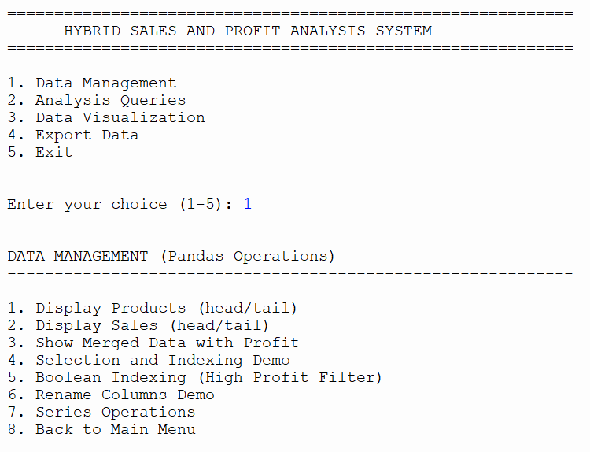

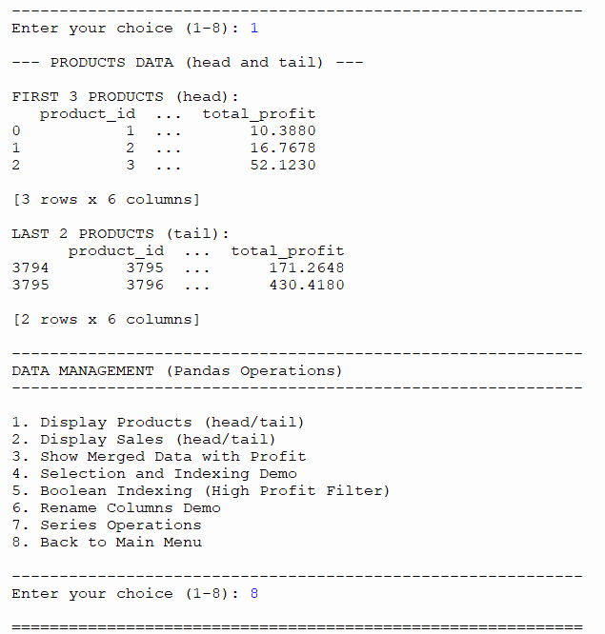
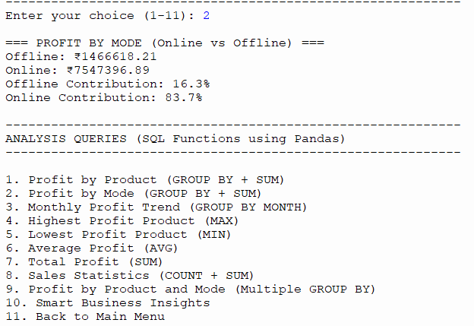
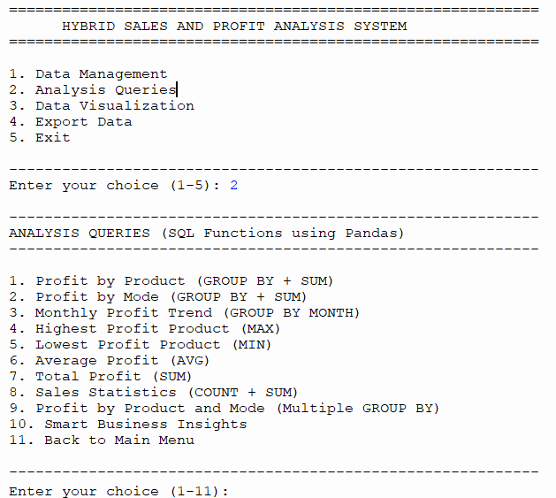

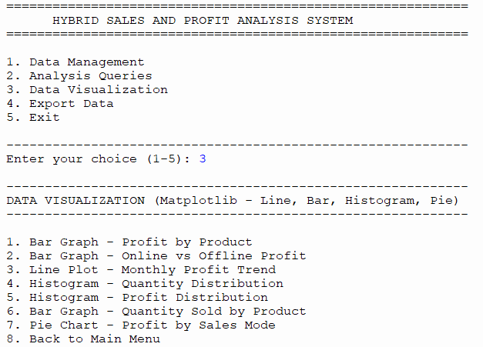
Figure 1. Console menu.

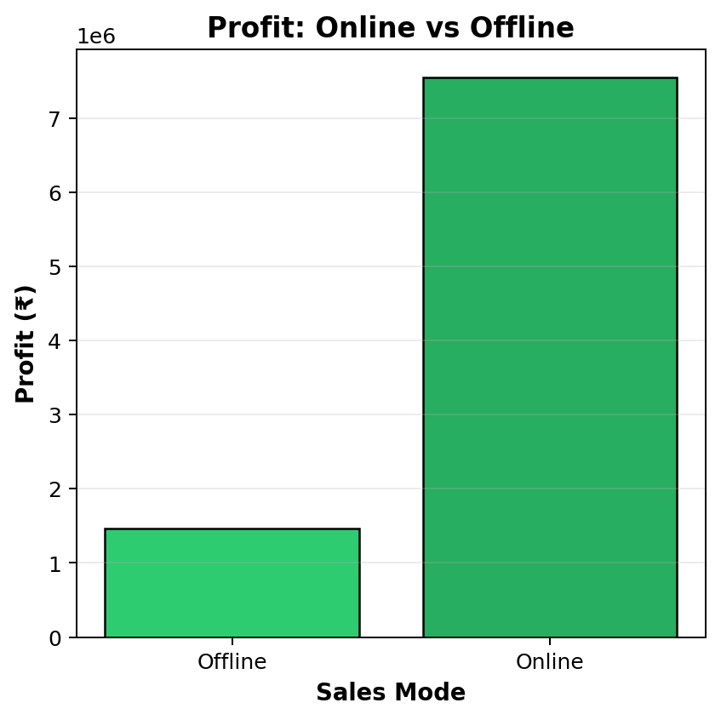
Figure 2. Profit by Sales Mode.
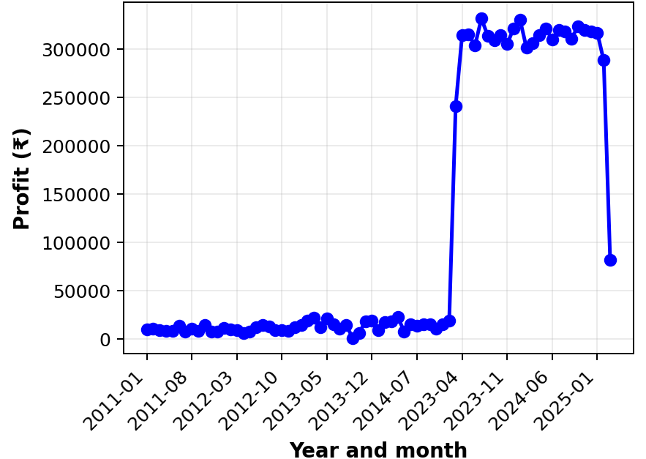
Figure 3. Monthly Profit Trend by Year-Month.

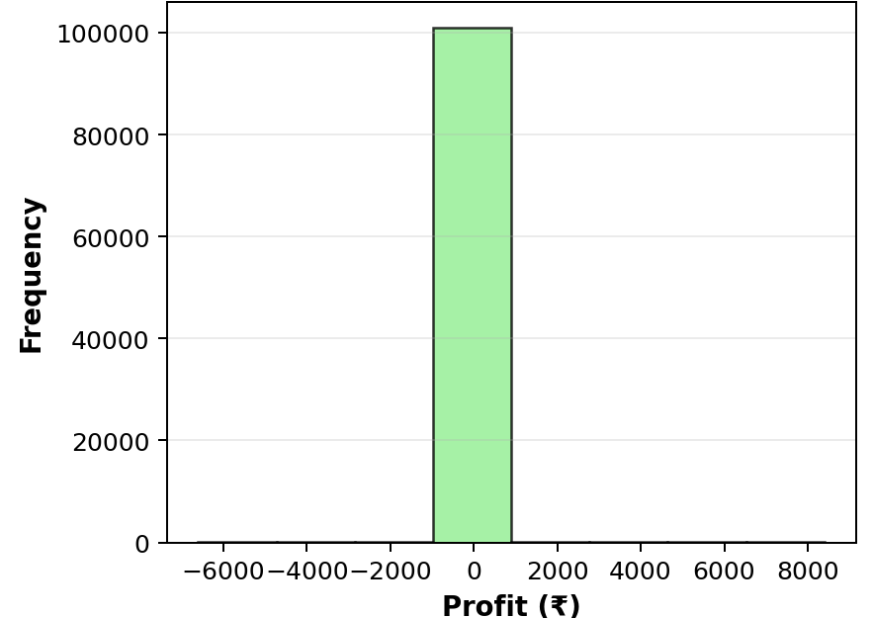
Figure 4. Profit Distribution.

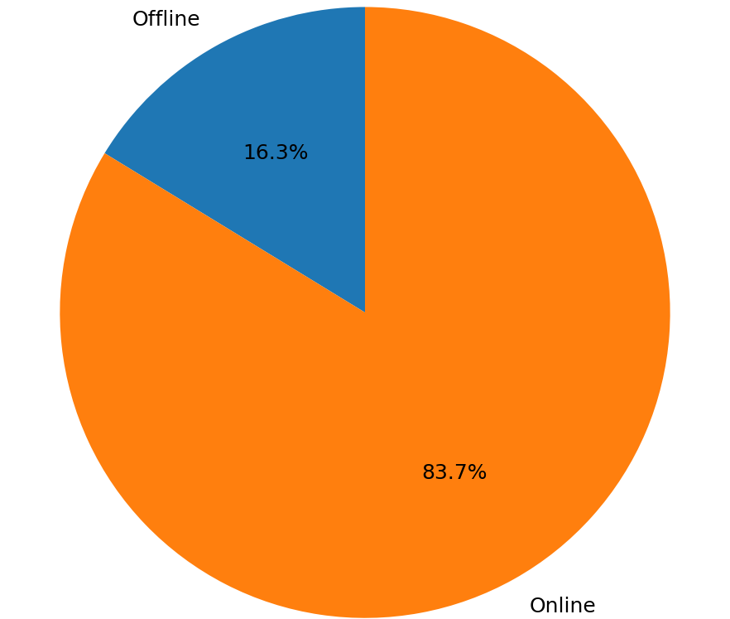
Figure 5. Profit Contribution by Sales Mode.

11. Graphical User Interface
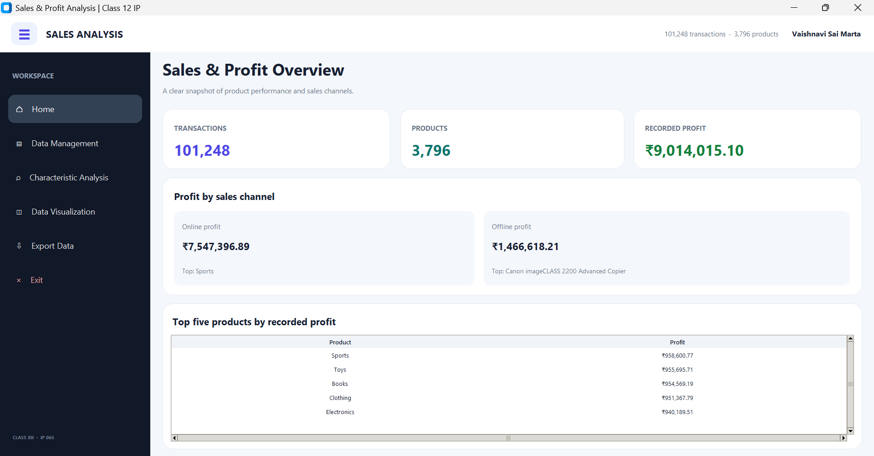

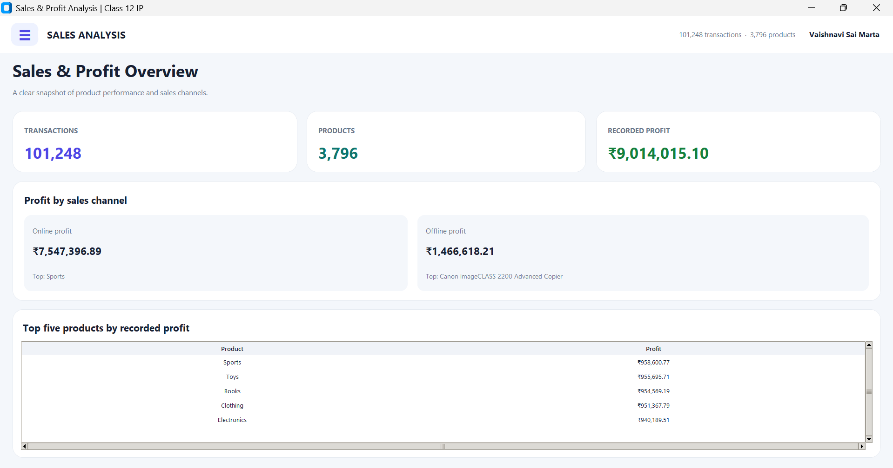
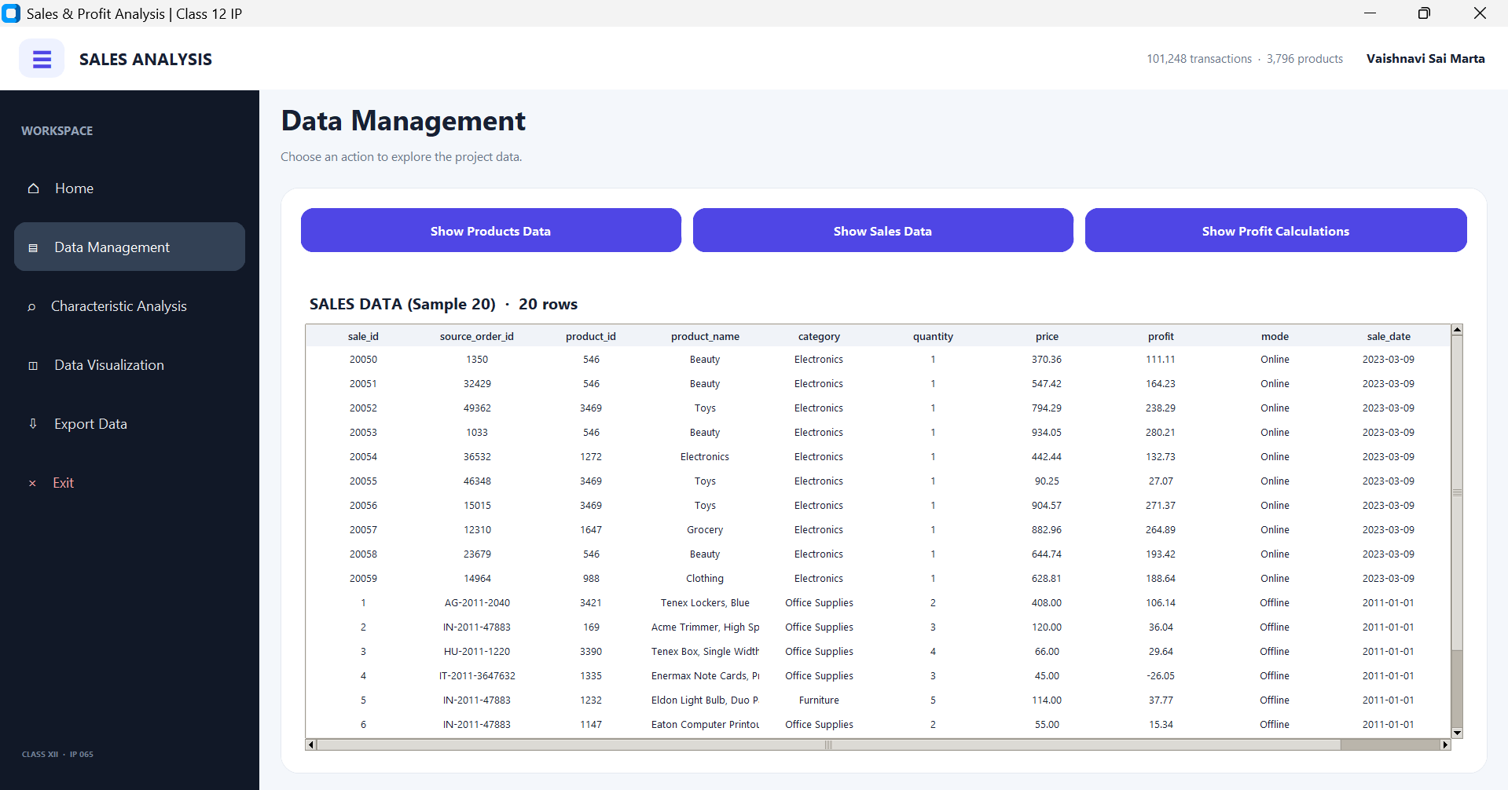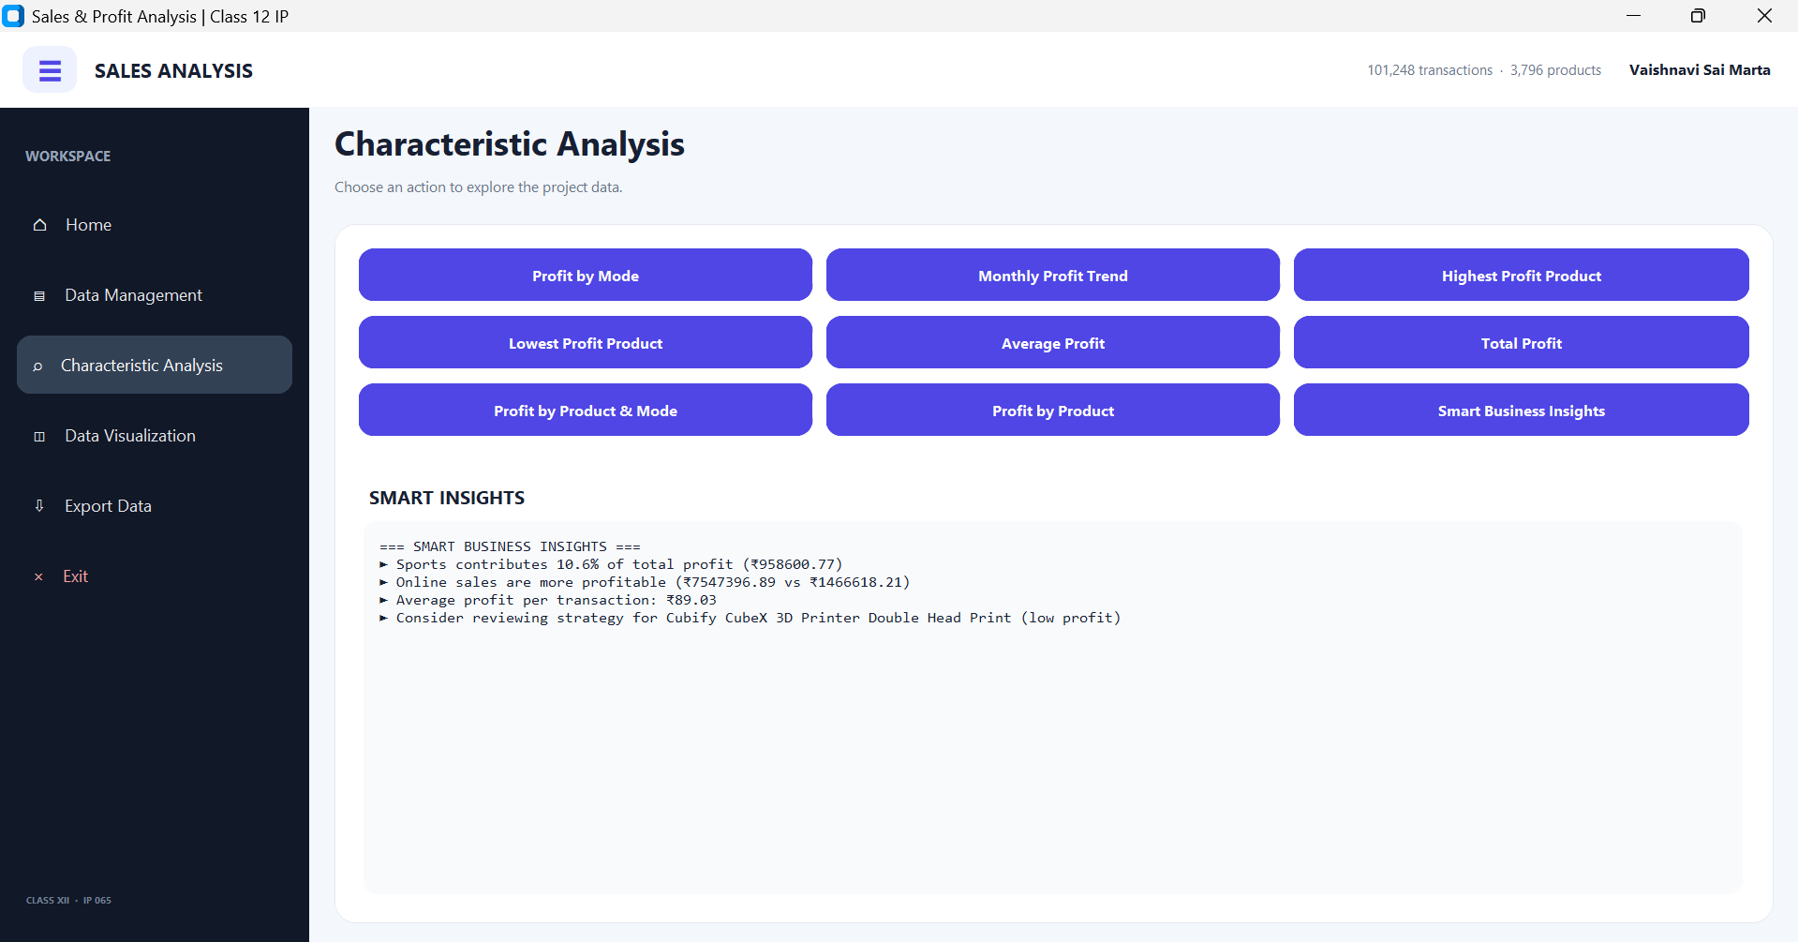
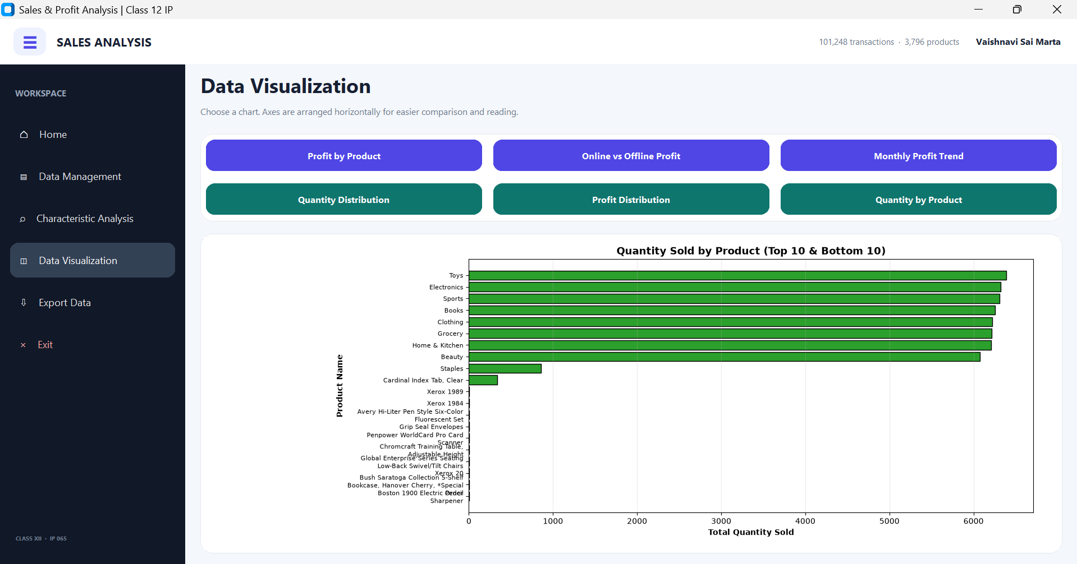
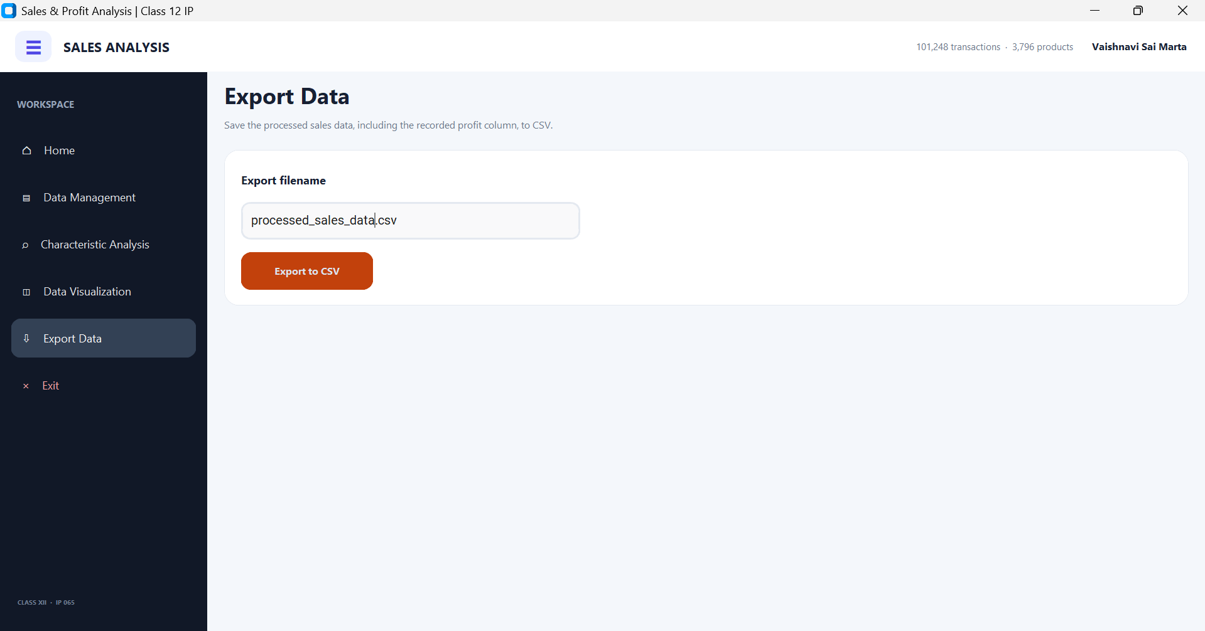

11. Conclusion
The Hybrid Sales and Analysis system demonstrates how Python can load, combine, summarise and export business data stored in CSV files Pandas can read and join CSV records, use DataFrames and Series, apply filtering and grouping, and summarize business information. Matplotlib displays comparisons, distributions, and year-month trends. The supplied data produces a total recorded profit of ₹9,014,015.10 across 101,248 transactions.
The review also corrected the product-price column mismatch in the verification script, prevented unsupported cost-price estimates, separated monthly totals by year, and made chart selections display their figures. Future improvements could add input validation reports, more CSV datasets, and documented data-entry features.
demonstrates how Python and Pandas can load, combine, examine, summarise, and export business data stored in CSV files. The project separates its work across four modules: main.py manages navigation, data_processing.py prepares the records, analysis.py produces numerical summaries, and visualization.py creates charts. The supplied dataset contains 3,796 product records and 101,248 sales transactions. The recorded total profit is ₹9,014,015.10, with ₹7,547,396.89 recorded for online sales and ₹1,466,618.21 for offline sales. These values describe the supplied data and should not be treated as proof of current business performance: the transaction dates contain gaps, and some rows have missing price values.

12. Bibliography and References
- Central Board of Secondary Education (CBSE), Academic curriculum portal; Informatics Practices, subject code 065. https://cbseacademic.nic.in/
- Python Software Foundation, Python 3 documentation: csv — CSV File Reading and Writing. https://docs.python.org/3/library/csv.html
- pandas documentation, IO tools (text, CSV, and related files). https://pandas.pydata.org/docs/user_guide/io.html
- pandas documentation, Group by: split-apply-combine. https://pandas.pydata.org/docs/user_guide/groupby.html
- Matplotlib documentation, Tutorials. https://matplotlib.org/stable/tutorials/
- Class XII Informatics Practices textbook prescribed by the school; enter the exact author, title, publisher, and edition used. Suggested authors include Preeti Arora and Sumita Arora.

